NGIatlantic.eu: insights from the results of the first Open Call

29 June 2020
One month after closure, the evaluation phase of the first NGIatlantic.eu Open Call is almost complete, which will select the winning projects from the 21 submitted proposals to be announced shortly. The unexpectedly high response to the first open call demonstrates a tremendous interest in transatlantic collaboration in NGI from SMEs and R&D actors alike throughout Europe and the US. The upcoming launch of the second Open Call, almost in synch with the results of the first open call, will give way to the continuous cycle foreseen, whereby each new call draws upon the lessons learned from the previous one(s), both in terms of the chosen topics and the overall EU – US twinning process.

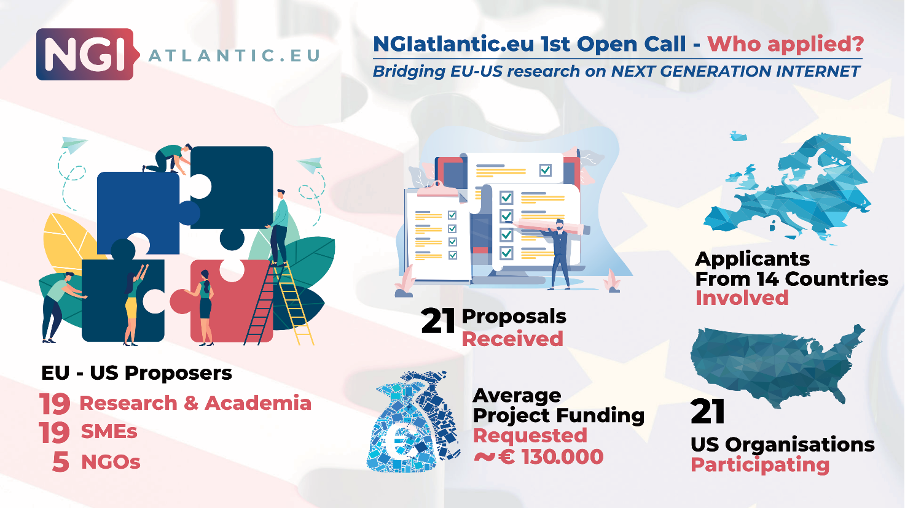

On 29th May 2020, NGIatlantic.eu closed its first Open Call for EU – US NGI projects with very successful results; a total of 21 EU – US proposals were submitted in the NGIatlantic.eu Trust Grant platform. The applying projects were all in the Long Term category with a six month duration and an average funding request of just over 130,000 euros. The submitted proposals provided good geographical coverage in both the EU and United States, a balance across the NGI key technologies and priority topics of the first call, and with EU coordinators from twelve different Member States.

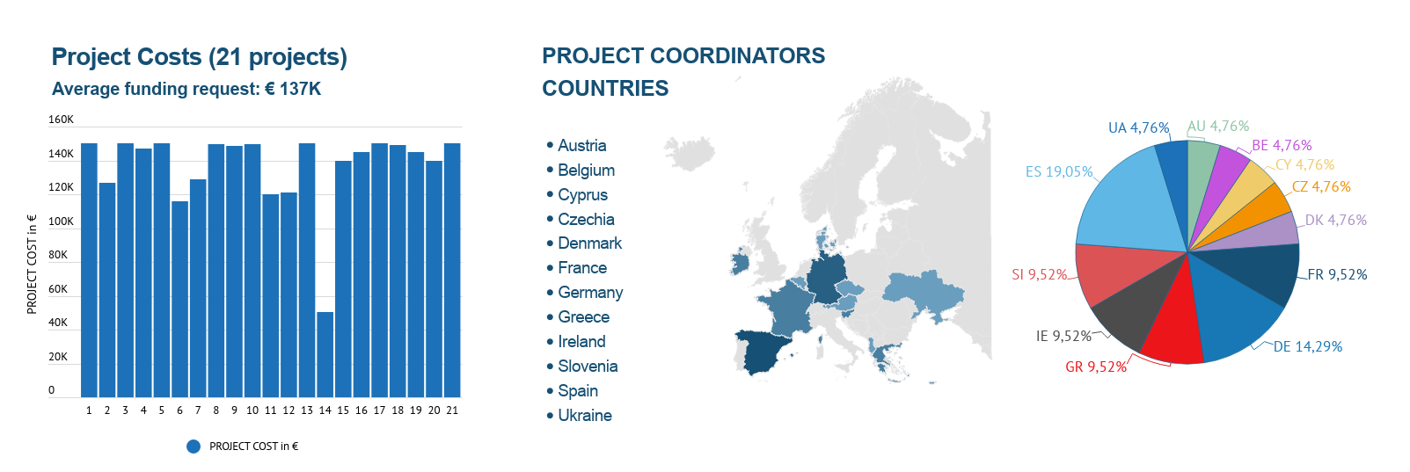

The 1st Open Call aimed at incentivizing EU – US NGI teams to carry out experiments of NGI results using EU and/or US based experimental platforms, such as Europe’s FED4FIRE+ and 5G-PPP, amongst others, and the US National Science Foundation (NSF) funded Wired and Wireless funded programs, such as ENTeR / GENI, FABRIC, and Future Cloud Platform, PAWR, US Ignite, and by the dedicated US-EU Internet Core & Edge (ICE-T) programmes. The project’s teams applied through the NGIatlantic.eu Trust Grant platform, which has been designed especially for the EU counterpart of the team to apply as the EU – US consortium leader.
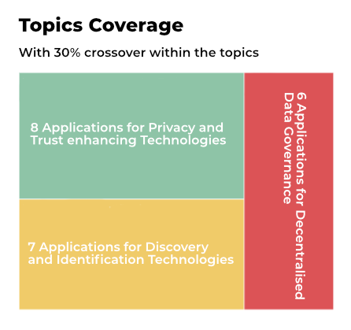
The results from this 1st Open Call show a good balanced coverage of NGI topics: the three NGI priorities for this first cycle of applications were Privacy and Trust Enhancing Technologies, with 8 applications received on this topic, Decentralised Data Governance, with 6 applications received, and Discovery and Identification Technologies with another 7 applications received. About 30% of the received proposals showed a crossover between topics also, which was expected.
As shown below, on the EU side, 15 of the applicants come from industry, mainly SMEs, 9 were submitted by Research/Academia, and 2 were submitted by non-profit organisations. On the US side, a high number of applicants were from Research & Academia (10), 8 from large companies & SMEs, and non-profit organisations (3).

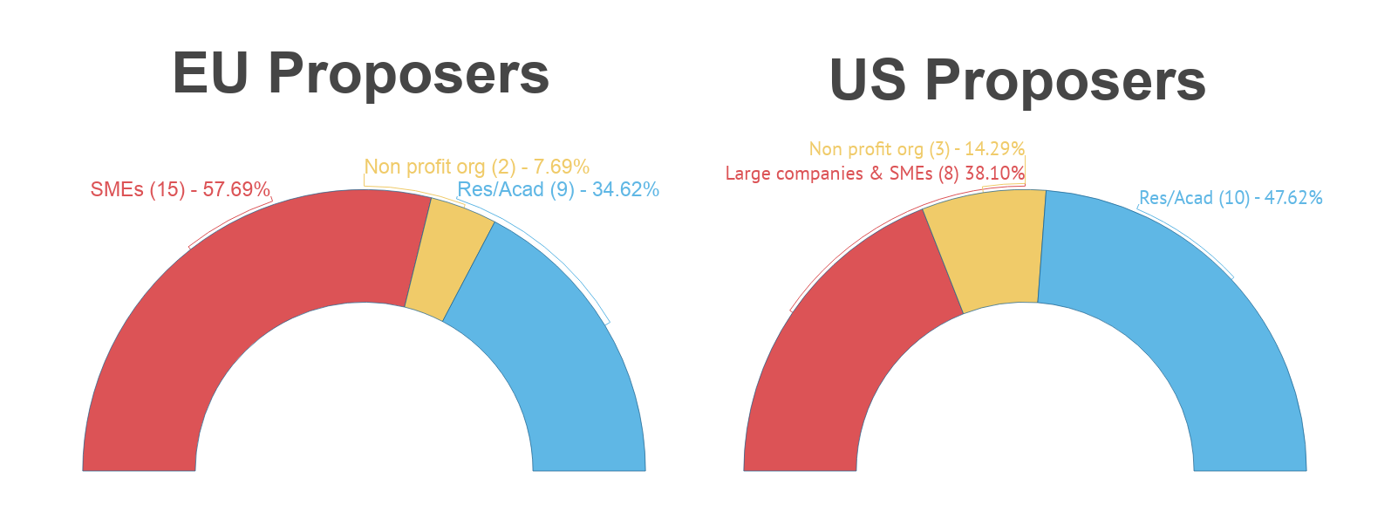

During the 1st Open Call, the NGIatlantic.eu project organised 2 proposer’s webinars to present the project, the topics, examples of the experimental platforms, sharing of proposal ideas with search for partners, and to enable potential applicants to ask the consortium direct questions about the open call. The recorded webinars can be found at https://www.ngiatlantic.eu/events/webinars.

The submitted applications are currently in the final phases of evaluation. The selected projects are expected to start their activities between August and September 2020.

On 3 August 2020, the next call cycle will continue with the launch of the second Open Call. Details will be available shortly at ngiatlantic.eu

About NGIAtlantic.eu
Started on 1 January 2020, over its 30 month lifetime, NGIatlantic.eu aims to promote collaboration between EU and US around the technical challenges posed by the vision of a more human-centric, Next Generation Internet, with a total 2.8 million Euros budget dedicated to funding a set of five 3rd party open calls for EU – US proposals. The funding is available for European organisations with a US-based counterpart, willing to bring the results of high-quality research & innovation activities onto NGI experimental platforms.
The whole Open Call process was entirely managed via the NGIatlantic.eu Trust Grant platform, from the selection of the External Pool of Evaluators (EPE) (continuous open here); to the overall Open call application process, evaluation assignments, and monitoring of the selected projects.

Contacts:

www.ngiatlantic.eu | @ngiatlantic | info@ngiatlantic.eu
LinkedIn: https://www.linkedin.com/company/ngiatlantic-eu/
Join our community: https://newsletter.ngiatlantic.eu/join-our-community

